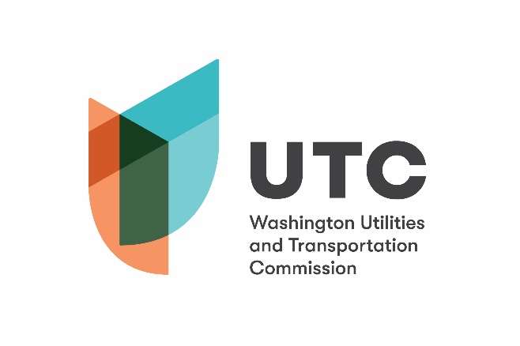 | 621 Woodland Square Loop SE  Lacey, WA 98503 Drive SW  PO Box 47250  Olympia, WA 98504-7250  (360) 764-0572 or (360) 292-7250  Web: www.utc.wa.gov

GRADE CROSSING PROTECTIVE FUND
AFFIDAVIT OF PROJECT COMPLETION

UTC Docket Number: TR-__________
(Use one affidavit for each GCPF grant/docket)

Award Recipient Information

Name:________________________________________________________________

Address:______________________________________________________________

Phone:___________________________ E-mail:___________________________

Project Completion Information: Attach additional sheets as necessary that provide the following:

- For projects involving multiple crossings, a list of the USDOT numbers assigned to each upgraded crossing approved under this docket for GCPF funding by the UTC.
- Photographs of each upgraded crossing with USDOT crossing number visible.

CERTIFICATION

This certification is to be completed by the representative of the award recipient.

Name (printed)______________________________Title________________________

I certify under penalty of perjury under the laws of the State of Washington that the railroad crossings identified in this form have been upgraded to the specifications outlined in the UTC order approving the Grade Crossing Protective Fund grant in this docket, and that the attached photographs accurately depict the improvements made at the upgraded crosings.

Signature_________________________________________________________

Date__________________________________ Place______________________
Submitting the Certification

Electronic submission is preferred. Send this completed certification with photographs, along with the A-19 Invoice Voucher and Expenditure Summary to:

Washington Utilities and Transportation Commission
Attention: Mike Turcott or Tyler Whitcomb
621 Woodland Square Loop SE
Lacey, WA 98503
PO Box 47250
Olympia, WA 98504-7250
mike.turcott@utc.wa.gov
tyler.whitcomb@utc.wa.gov

Assistance

For questions or assistance, please contact the following UTC staff:
Mike Turcott at (360) 664-1119 or mike.turcott@utc.wa.gov
Tyler Whitcomb at (564) 669-0943 or tyler.whitcomb@utc.wa.gov

