Issue Brief 2

Climate Legislation in Washington State

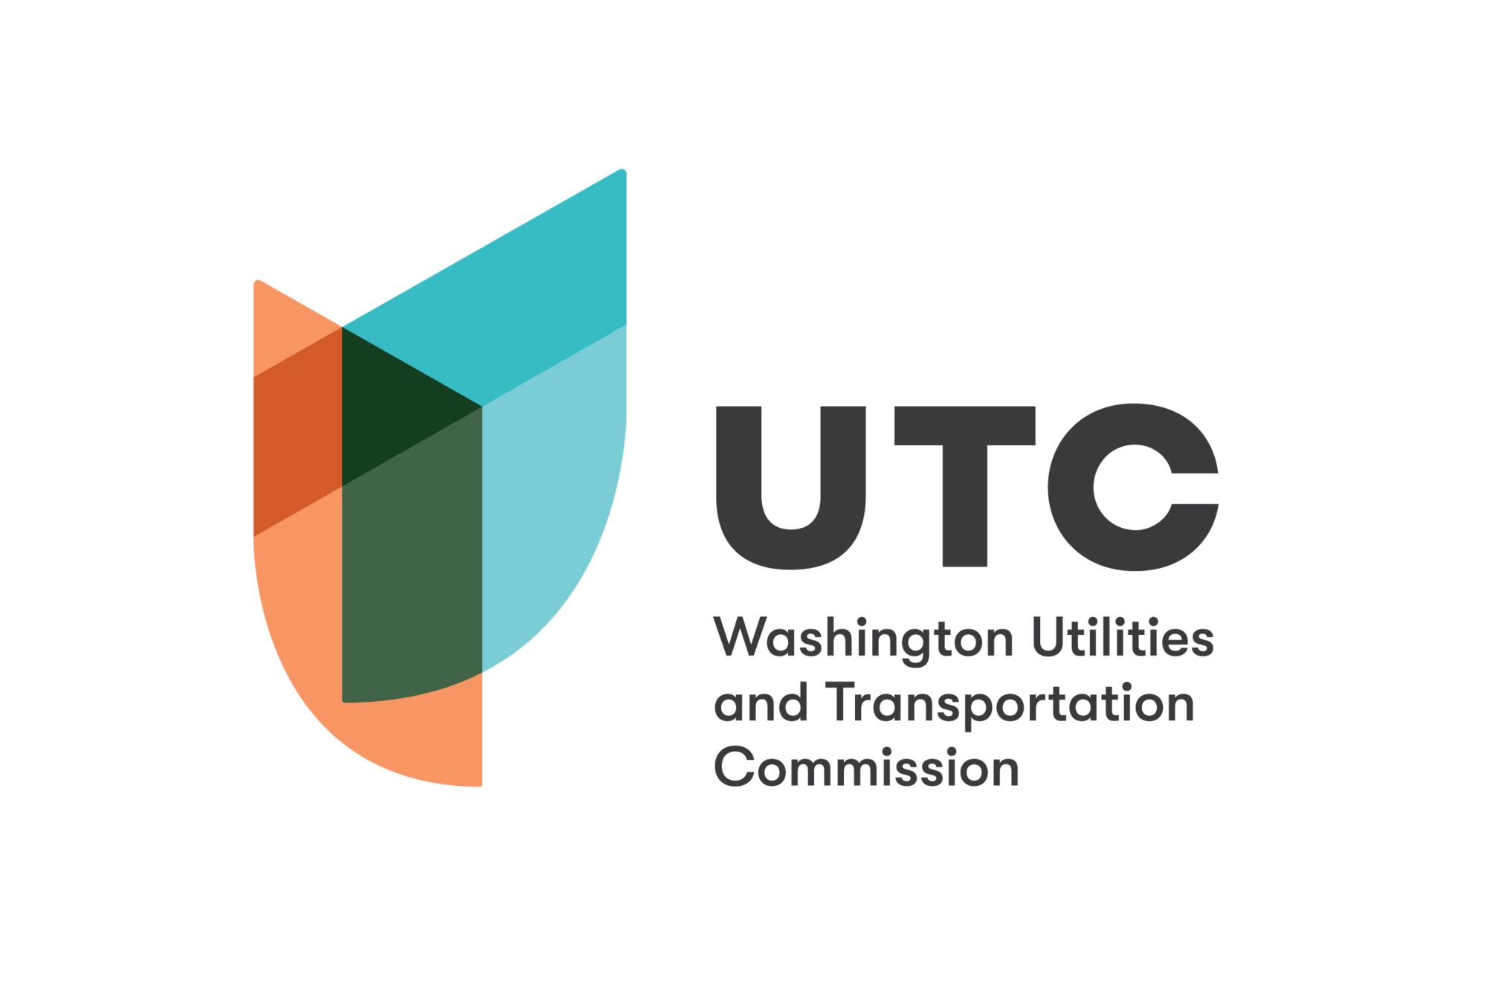

Climate Legislation in Washington

Washington’s Climate Targets
In 2020, the Washington State Legislature passed HB2311 (Chapter 79, Laws of 2020), which set a target to reduce the state’s greenhouse gas emissions 45% below 1990 levels by 2030, 70% below 1990 levels by 2040, and 95% below 1990 levels (and achieve net zero emissions) by 2050. Since emissions in 2022 were higher than in 1990, Washington must reduce emissions by 48% between now and 2030 to achieve its interim goal. Achieving the 2050 target “will require all sectors of the economy to reduce emissions at a rapid pace,” according to the Washington State Energy Strategy. With these new targets in place, Washington State has some of the most ambitious energy and emissions goals in the United States.

Decarbonizing the Energy System
In order to achieve Washington’s climate targets, the state must drastically reduce the use of fossil fuels to decrease greenhouse gases emitted into the atmosphere, a process referred to as decarbonization.
Approximately 13% of electricity produced in Washington is generated by burning natural gas. Washington’s Clean Energy Transformation Act requires 80% of electricity used in Washington to come from renewable or non-emitting sources by 2030, and allows the remaining 20% to be carbon-neutral via off-sets or other compliance mechanisms. CETA also mandates that, by 2045, all electricity in Washington must come from clean energy sources.
Additionally, the Energy Decarbonization Pathways Examination (for which this brief has been produced) was mandated by Section 143(4) of the 2021-23 Omnibus Operating Appropriations Act (SB 5092).
Emissions associated with natural gas use in buildings must decrease by 14% by 2030 to meet the state’s overall GHG reduction targets, according to the Washington State 2021 Energy Strategy. One third of homes in Washington use natural gas for space heating. Beyond home heating, natural gas is used as a fuel source for water heating and cooking, particularly in the cold climates of central and eastern Washington. National surveys indicate that approximately half of commercial buildings and more than two-thirds of building floorspace (70%) used natural gas in Washington in 2018.

Laws Supporting Decarbonization
The Washington State Legislature has passed a variety of laws in the two most recent legislative sessions to support energy sector decarbonization. These laws enable the state to:
- Monitor and regulate state-wide emissions via a new cap-and-invest program overseen by the Department of Ecology. Some entities will receive free allowances at the beginning of the program. The emissions cap will decrease over time, meaning fewer allowances will be available for purchase or trading. Program rules are currently in development. (Climate Commitment Act, Chapter 316, Laws of 2021 [partial veto])
- Reduce energy use by improving the efficiency of new commercial and residential buildings, requiring on-site electricity generation for new large buildings, setting energy and emissions standards for new buildings, and encouraging utilities to plant trees and install cool roof technology. (Clean Buildings for Washington Act, Chapter 285, Laws of 2019; Commercial Property Clean Energy and Resiliency Financing, Chapter 27, Laws of 2020; Urban Heat Island Effects - Utility Mitigation, Chapter 11, Laws of 2021)
- Increase opportunities for Washingtonians to generate solar or wind power at their home or business and get billing credit from electricity utility companies. Utilities are now required to make 10-year plans based on data and scenario modeling for how they will incorporate distributed energy and net metering into their resource plans. Utilities are required to continue to offer net metering at normal customer rates until 2029 or when the cumulative generating capacity equals 4% of the utility’s peak demand in 1996 (Enabling Electric Utilities to Prepare for the Distributed Energy Future, Chapter 205, Laws of 2019; Concerning Net Metering, Chapter 235, Laws of 2019)
- Improve access to information about the energy system by requiring natural gas utilities to make data on leaks in the gas system more transparent and accessible and requiring electric utilities to use an “electricity product content label” that discloses electricity sources for the previous year. (Natural Gas Transmission and Distribution, Chapter 32, Laws of 2020; Electricity Product Attributes, Chapter 222, Laws of 2019)
- Encourage the exploration of alternative energy sources such as renewable hydrogen by creating an Office of Renewable Fuels within the Department of Commerce to leverage, support, and accelerate the development of renewable fuel infrastructure.
- Adopt California’s Zero Emissions Vehicle standards, which will require car manufacturers to offer for sale amounts of the least polluting cars available, which includes full battery-electric, hydrogen fuel cell, and plug-in hybrid-electric vehicles. (Renewable Hydrogen, Chapter 292, Laws of 2022; Reducing emissions by making changes to the clean car standards and clean car program, Chapter 143, Laws of 2020)
- Incentivize the adoption and use of electric vehicles by providing tax credits, exemptions, grants, and technical support for electric and alternative vehicle purchases; requiring new commercial buildings to include EV charging infrastructure; and encouraging utilities to invest in infrastructure, programs, and services to support EV adoption. (Advancing Green Transportation, Chapter 287, Laws of 2019; Move Ahead Washington Chapters 186 and 187, Laws of 2022; Zero-Emission Vehicles - Preparedness, Chapter 300, Laws of 2021; Transportation Electrification, Chapter 109, Laws of 2019).

Further Information
- Tracking Greenhouse Gases - Washington State Department of Ecology
- Clean Energy Transformation Act Rulemaking - Washington State Department of Ecology
- Climate Commitment Act - Washington State Department of Ecology
- Assessment of Washington State Natural Gas Company GHG Emissions (2019) - State of Washington Utilities and Transportation Commission
- Washington State Greenhouse Gas Emissions Inventory: 1990-2018 - Washington State Department of Ecology
- 2021 Washington State Energy Strategy - Washington State Department of Commerce
- Bill Information Database - Washington State Legislature

Sources
- Roberts, David, “Washington State Now Has the Nation’s Most Ambitious Climate Policy,” Volts.Wtf, accessed February 11, 2022, https://www.volts.wtf/p/washington-state-now-has-the-nations.
- U.S. Census Bureau, Washington, Table B25040, House Heating Fuel, 2019 American Community Survey 1-Year Estimates.
- “WA 2021 State Energy Strategy,” Washington State Department of Commerce, accessed February 11, 2022, https://www.commerce.wa.gov/growing-the-economy/energy/2021-state-energy-strategy/
- U.S. Energy Information Administration, Washington Natural Gas Consumption by End Use [data set], accessed June 16, 2022, https://www.eia.gov/dnav/ng/ng_cons_sum_dcu_SWA_a.htm.

