Issue Brief 3

Energy and Equity in Washington State

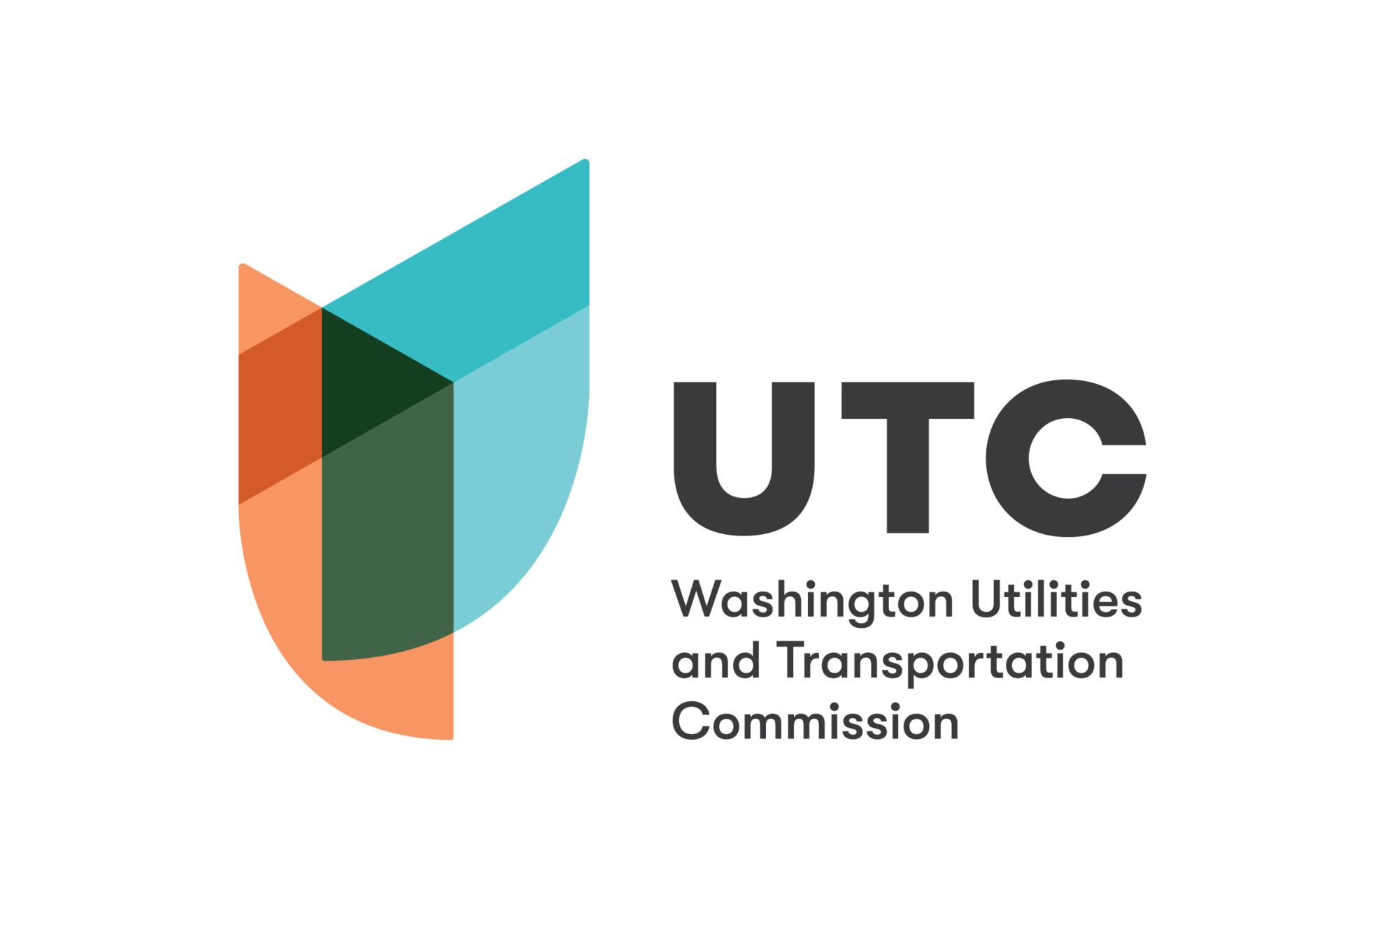

Energy and Equity in Washington
Low-income households across the United States face high energy costs that can make it difficult for them to meet their household needs. In 2020, one-tenth (9.5%) of Washingtonians lived in poverty and, in 2018, one in four Washington residents struggled to make ends meet. Additionally, between 2017 and 2019, 9.9% of households, on average, were food insecure. During the pandemic, the rate of food insecurity increased to 27%. Poverty is more prevalent east of the Cascades (see Figure 3).
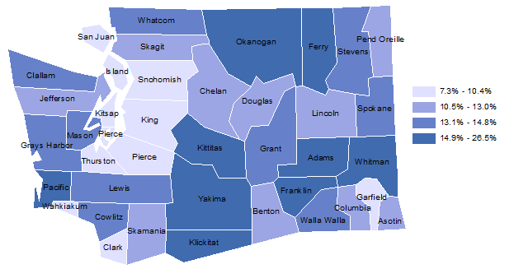

Figure 1. Percent of families in poverty in Washington, 2019 (Source: Washington Office of Financial Management).
Low-income households tend to have high energy cost burdens in part because their homes tend to be draftier, older, and have poorer insulation than those of wealthier households, making them energy inefficient. According to the U.S. Department of Energy, cost-effective energy efficiency measures, such as improving insulation and installing more efficient appliances, have the potential to reduce energy use by 13-31%.
A household faces a high energy burden when it spends more than 6% of its income on energy and a severe energy burden when it spends more than 10% of its income on energy. In 2018, 11% of low-income households across Washington faced a high or severe energy burden (defined as households below 200% the federal poverty level and energy burdened in excess of 6%).
Energy burdens tend to be higher among Black, Hispanic, and Native American households, as well as elderly households. For example, an analysis of household energy burdens in Seattle found that 14% of Black households and 15% of Hispanic households in the area experience a high energy burden (above 6%), compared to a citywide median energy burden of 1.8%. The study also found that the median energy burden of Black households in Seattle is 28% higher than that of non-Hispanic white households.
The rate of high energy burden in low-income households varies across Washington. Thirty-seven percent of low-income households in Ferry County experience a high energy burden, compared to 6% in Snohomish County. Largely rural counties in the eastern two-thirds of the state tend to face higher household energy burden levels; in many of them, the low-income household energy burden exceeds 20%. These numbers are in line with national trends: rural American households have a median energy burden three times higher than urban ones.

Recent Legislation and Energy Equity
Legislation passed in the 2019, 2020, and 2021 legislative sessions includes provisions to consider the equity implications of the costs and benefits of decarbonizing the energy system and activities within the state.
The Clean Energy Transformation Act requires utilities to consider the social cost of emissions—in other words, the economic cost of emitting 1 additional ton of a greenhouse gas into the air. Additionally, utilities must assess the impact of their operations on vulnerable and highly impacted communities. CETA also requires all utilities to create low-income energy assistance programs to ensure the clean energy transformation will be equitable and reduce the energy burden of vulnerable and highly impacted communities. In response to CETA, the UTC adopted new rules requiring utilities to create utility advisory groups to discuss the equitable distribution of benefits and reduce harm to overburdened communities.
The Healthy Environment for All Act, Washington’s first environmental justice law, requires seven state departments, including Commerce and Ecology, to operationalize environmental justice practices and procedures within their work. This includes developing environmental justice assessments to identify environmental justice impacts caused by significant agency actions, such as loan programs, legislative rules, or budget and funding assessments. HEAL also authorized the creation of an Environmental Justice Council that advises the seven departments on incorporating environmental justice into their plans, budgets, and policies. The Environmental Justice Council brings together environmental justice advocates, practitioners, and state agency representatives.
Passed in 2021, the Climate Commitment Act (CCA) establishes an emissions cap-and-invest program for carbon emissions, set to start in 2023. In order to emit greenhouse gases, energy sector organizations (and others), must purchase a greenhouse gas allowance in an action. Proceeds will be used to advance the transition to clean energy, transportation, and climate resiliency. Thirty-five percent of the funds must go towards projects serving overburdened communities and 10% must go to Tribal projects.
The Environmental Justice Council (see above) makes recommendations to the State Legislature regarding projects funded by the CCA and monitors the progress of CCA-funded projects on their environmental justice goals. The council also reviews CCA-funded projects every two years to check their progress on decreasing emissions and pollutants. Ecology must adopt additional measures if sufficient reductions have not occurred.

Sources
- American Council for an Energy-Efficient Economy, “Energy Burdens in Seattle,” September 2020, https://www.aceee.org/sites/default/files/pdfs/aceee-01_energy_burden_-_seattle.pdf.
- Drehobl, Ariel, et. al, “How High Are Household Energy Burdens? An Assessment of National and Metropolitan Energy Burden across the United States”, (American Council for an Energy-Efficient Economy, 2020), https://www.aceee.org/research-report/u2006.
- Ellison, Jake, “Food Insecurity Remains High and Need for Assistance Dramatically up in Washington,” UW News (blog), July 30, 2021, https://www.washington.edu/news/2021/07/30/food-insecurity-remains-high-and-need-for-assistance-dramatically-up-in-washington/.
- Governor Inslee’s Poverty Reduction Workgroup, “Interim Progress Report,” October 2018, https://www.governor.wa.gov/sites/default/files/PRWG_2018InterimProgressReport_FINAL.pdf.
- Talk Poverty, “Washington Report - 2020,” accessed March 26, 2022, https://talkpoverty.org/state-year-report/washington-2020-report/.
- “U.S. Census Bureau QuickFacts: Washington,” accessed March 22, 2022, https://www.census.gov/quickfacts/WA.
- U.S. Department of Energy Office of Energy Efficiency & Renewable Energy, “Low-Income Household Energy Burden Varies Among States - Efficiency Can Help In All of Them”, December 2018, https://www.energy.gov/sites/prod/files/2019/01/f58/WIP-Energy-Burden_final.pdf.
- Washington State Department of Commerce. Revised: Statewide energy burden data [RCW 19.405.120(3).], (April 29, 2021), distributed by Washington State Department of Commerce, https://deptofcommerce.app.box.com/s/czuj8tqaj9i5i7c8gyhld8htscbn9xsk.
- Washington State Department of Ecology, “Climate Commitment Act”, accessed July 20, 2022, https://ecology.wa.gov/Air-Climate/Climate-change/Climate-Commitment-Act.
- Washington State Department of Ecology, “HEAL - Washington State Department of Ecology”, accessed July 20, 2022, https://ecology.wa.gov/About-us/Who-we-are/Environmental-Justice/HEAL.
- Washington State Office of Financial Management, “Families in Poverty, Families with Children under Age 18 in Poverty, Individuals in Poverty, Individuals Age 65 and Older in Poverty”, accessed March 25, 2022, ​​https://ofm.wa.gov/washington-data-research/statewide-data/washington-trends/social-economic-conditions/families-poverty-families-children-under-age-18-poverty-individuals-poverty-individuals-age-65-and-older-poverty​​.
- Washington Utilities and Transportation Commission, “Clean Energy in Washington State - SB 5116 Fact Sheet,” accessed July 20, 2022, https://www.utc.wa.gov/sites/default/files/2021-02/5116%20Fact%20Sheet.pdf.
- Washington Utilities and Transportation Commission, “UTC Rolls out New Clean Energy Rules”, January 5, 2021, https://www.utc.wa.gov/news/2021/utc-rolls-out-new-clean-energy-rules.

